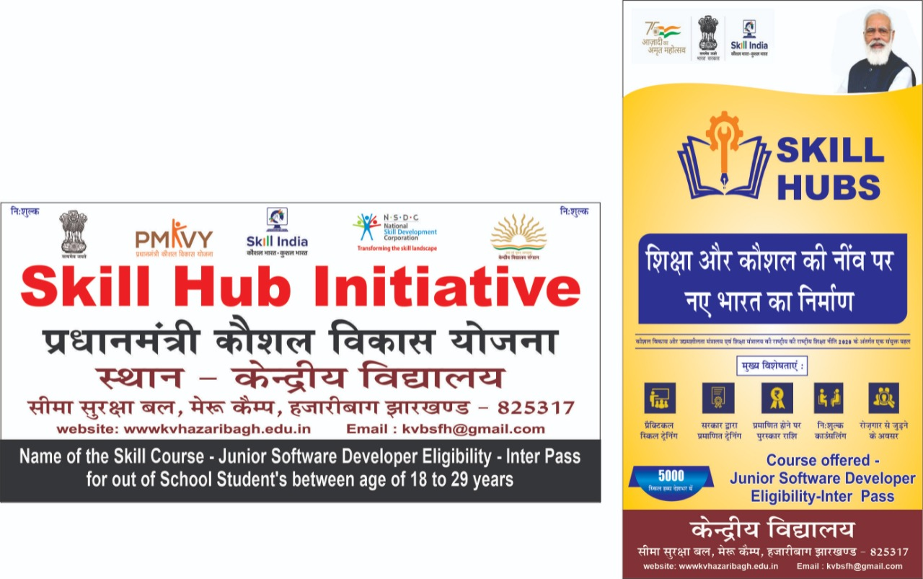
SKILL HUB INITIATIVE
(A Govt. Of India initiative through National Skill Development corporation)
KENDRIYA VIDYALAYA HAZARIBAGH
OFFER

A Golden opportunity to the school / college drop-outs to build their skills as a
“Junior software Developer”

COURSE DETAILS
- Course – skill training for job role of a junior software Developer.
- Training Time: - After school hours – 2:30 to 5:50 PM.
- Training Location- KENDRIYA VIDYALAYA BSF MERU CAMP HAZARIBAGH, JHARKHAND-825317
- Commencement of training – 30- Jan- 2022.

ELIGIBILITY
Education- class-12 pass (School/college/ drop out, Indian Citizen)
Age - 18-29 Years
No fees! It is absolutely free!
Certificate will be issued on successful completion of the training program

Registration
Start- from 12:30 AM to 01:M on 27.12.2021
Bring your Aadhar card, DOB Certificate & Mobile Number.
(All Compulsory for registration)

Hurry!! Limited seats, Registration closes on first come first serve basis.

For queries 7258956799, 7061385238
Website: https//bsfhazaribagh.kvs.ac.in
Email: kvbsfh2gmail.com

